Math 1 Name ______________________________
4-3 Practice Date________
- I can define an exponential function.
- I can determine if a function is linear or exponential given the sequence, graph or table of values.
- I can identify the quantity being compared and write explicit/recursive equations to describe a real-world problem.
- I can use technology to find the point where two functions intersect.
- I can determine the practical domain and range in the context of a problem. And explain how they are related to the graph.
When people cough or sneeze, they spread germs. Suppose one of your group members sneezes on you by accident. The germs they just sprayed all over you are continually reproducing and creating more germs at a very fast rate. Let’s say that 5 germs land on you from your partner’s sneeze. Every hour the number of germs triple…
1. What is the initial amount of germs in this situation?
2. What is the growth factor in which these germs reproduce per hour?
3. Write a recursive rule to represent this situation.

4. Write an explicit rule in function notation, using g for number of germs and h for hours.

5. How many germs will be on you in just 3 hours?

6. How long until there are 885,735 germs on you?

7. How many germs will be on you in 1 day, assuming you haven’t showered yet?

8. What is the domain and range for this situation?
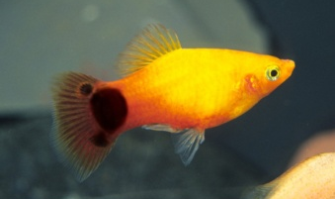
9. A local fish supply company started off with 6 Mickey Mouse fish in their aquarium and noticed that they were having babies twice a year. After each set of babies were born, the population of fish in the aquarium increased by an average of 30% every 6 months.
a. Write a recursive formula that models the number of fish in the aquarium.

b. Write an explicit formula in function notation that models the number of fish f in the aquarium for any number of six-month periods m.

c. How many fish will be in the aquarium after 2 years?

d. How many fish will be in the aquarium after 3.5 years?

e. When will the number of fish in the aquarium be at least 22,000 fish? (Assuming they own a very large aquarium)

10.

11. Evaluate the following:
a. 5⁴ = b. (-7)² = c. -7² =

d. (-8)³ = e. 2⁸ = f. 2⁰ =

12. Find the missing terms in the following geometric sequence.
22, _______, _______, _______, 111.375

13. Write an explicit formula for the sequence from number 12 then find the 7th term. Round your answer to the nearest thousandth.

